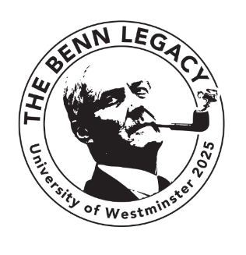
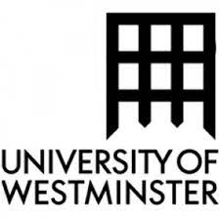

The Benn Legacy

A conference to be held on 12-13 April 2025 at the University of Westminster in commemoration of the 100th anniversary of Tony Benn’s birth, looking at Benn’s life and legacy.

The issues to which Benn devoted his political life are, if anything, more burningly relevant today than they were when he died in 2014. These include the relationship of people to power, peace in the Middle East, Britain and Europe, the state of the House of Lords and socialism within the Labour Party.

In keeping with his principles, the conference aims to be inclusive, inviting contributions from the academy but also reaching out to trade unions and activist groups. To this end, there will be travel/accommodation bursaries to enable people to attend who are from groups not normally represented at conferences.

Papers of 10-20 minutes are welcomed on any aspect of Benn’s life and legacy.
Topics may include but are not limited to:

- Congregationalism/nonconformist contribution to political thought
- Movement for Colonial Freedom
- The peerage
- Technology (notably the post office and Mintech)
- 1960s radicalism
- Referendum 1975 (and reflections on 2016)
- Manufacturing industry in the 1970s and 80s
- Coal and the miner’s strike
- The Falklands War
- Gulf War 1
- Iraq, anti-war protests
- Radicals in the House of Commons
- Political diaries
- The Benn Archive

Abstracts (up to 300 words) and biographies (up to 100 words) should be submitted in Word to Pippa Catterall and Jad Adams: p.catterall@westminster.ac.uk and jadadams@btinternet.com by 31 October 2024.

